**End-to-End CI/CD Pipeline with AWS & GitHub Integration**

This project demonstrates the implementation of a fully automated CI/CD pipeline using **AWS services** integrated with **GitHub**, enabling streamlined build and deployment processes to an EC2 environment.

**Key Components & Workflow**

* **GitHub Integration with AWS**  
  Established a secure and authenticated connection between GitHub and AWS services to enable automatic source code retrieval and build triggering.
* **Amazon S3 Bucket Setup**  
  Configured an S3 bucket to serve as a centralized location for storing build artifacts (ZIP packages) ready for deployment.
* **AWS CodeBuild Configuration**
  + Set up a CodeBuild project to pull the source code from the GitHub repository.
  + Utilized a custom buildspec.yaml file to define build instructions.
  + Packaged the application into a ZIP file and stored the output in the S3 bucket.
* **IAM Role Creation for CodeDeploy**
  + Created a dedicated IAM role with the necessary permissions for AWS CodeDeploy.
  + Updated the trust policy to authorize CodeDeploy to assume the role.
* **Amazon EC2 Instance Provisioning**
  + Launched a virtual machine (EC2 instance) and attached the IAM role for seamless deployment.
  + Ensured the EC2 instance was properly configured to interact with CodeDeploy.
* **AWS CodeDeploy Application & Deployment Group**
  + Created a CodeDeploy application and associated deployment group targeting the EC2 instance.
  + Configured deployment settings to retrieve the latest build artifacts from the S3 bucket.
* **Deployment Execution**
  + Successfully triggered deployments using artifacts stored in S3, automatically deploying

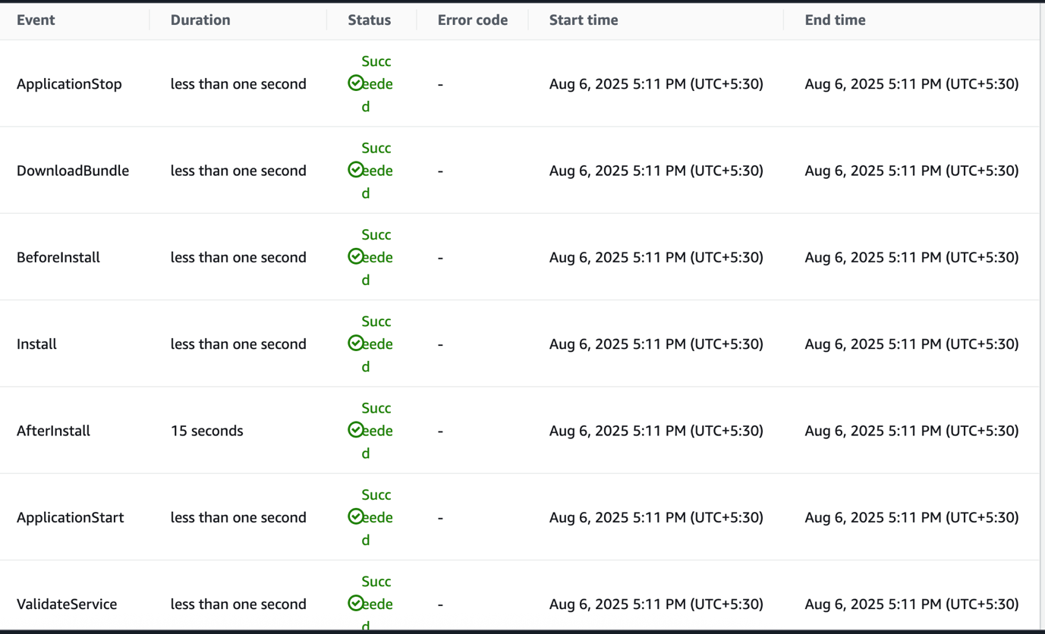 the application to the EC2 instance via CodeDeploy.

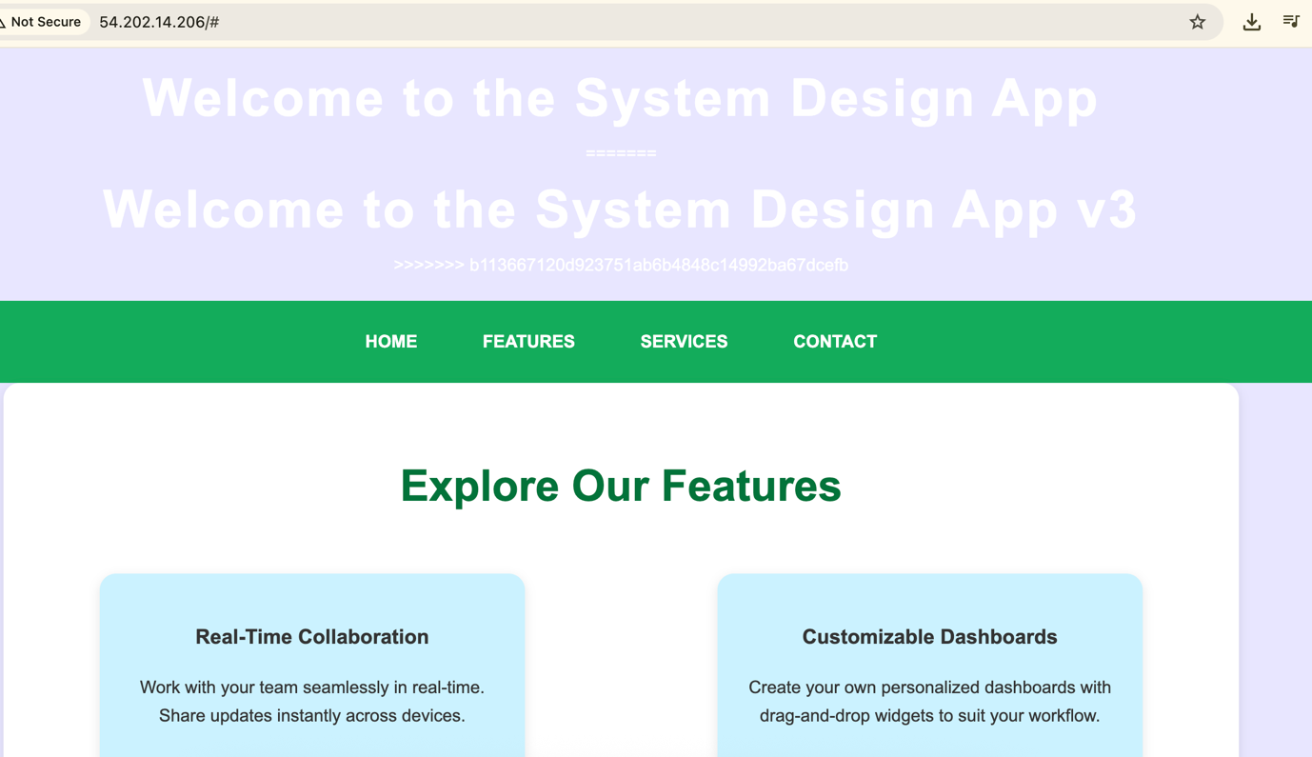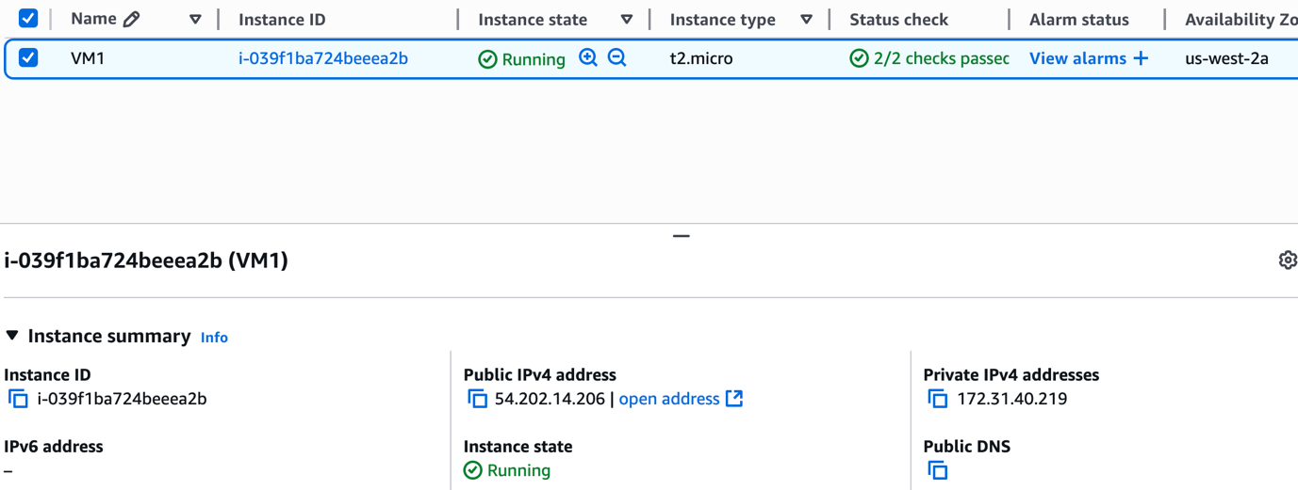

* Automated the code pipeline

